**HOMEWORK-1**

**BIOL 5385: Molecular Evolution.**

**NAME: Lipi Vikram Thakker**

**Collaboration with: Freya Hammer and Ketki Joshi**

**ASSIGNMENT SOLUTIONS**

**NOTE:**

**MATLAB setup: MATLAB via giant using VPN as per the instruction given by tech department.**

**ANSWER 1:**

Below is the demonstration of genetic drift script. Each experiment consist of 3 plots with 3 different values of population, generation and allele probability.

**CASE 1:** In this experiment, change the size of the **population** while the other parameters remain constant.

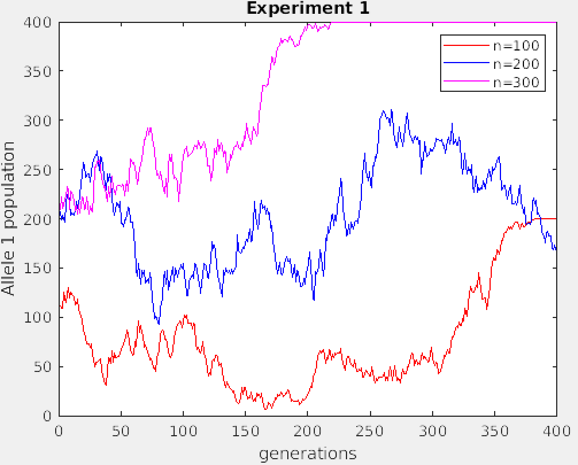

**CASE 2:** In this experiment, change the size of the **probability** while the other parameters remain constant.

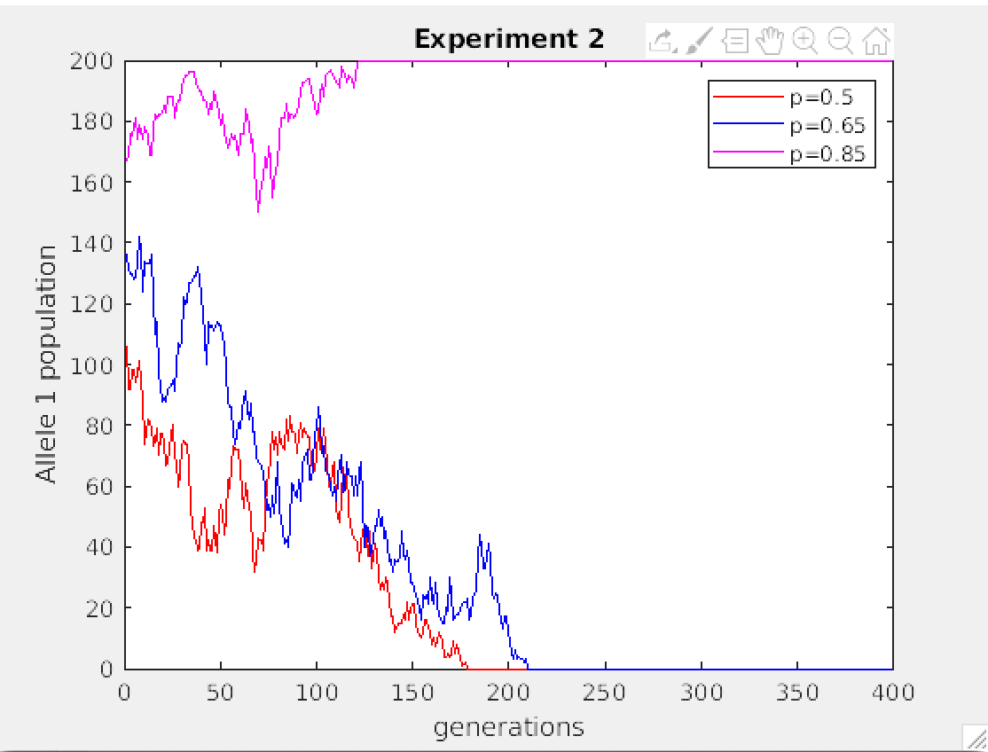

**CASE 3:** In this experiment, change the size of the **generation** while the other parameters remain constant.

